|  |  |
| --- | --- |
|  | |
| **OCN NI Use Only** | |
| **Q** | **Mark** |
| 1a |  |
| 1b |  |
| 1c |  |
| 1d |  |
| 1e |  |
| 1f |  |
| 1g |  |
| 1h |  |
| 2a |  |
| 2b |  |
| 2c |  |
| 2d |  |
| 2e |  |
| 2f |  |
| 2g |  |
| 3a |  |
| 3b |  |
| 3c |  |
| 3d (i) |  |
| 3d (ii) |  |
| 3e |  |
| **Total** |  |

**OCN NI Level 1 Certificate in Essential Skills**

**Application of Number**

**The Farewell**

**Learner name (Block Capitals)**

**Learner signature**

**Centre**

**Assessment date**

Candidate Mark %

Pass Mark %

|  |
| --- |
| **Instructions to candidates:**  **You should have the following for this assessment:**   * Pen with black or blue ink * Pencil and eraser * 30 cm ruler * Calculator * Protractor   **General Instructions:**   * There are 3 tasks to complete * You should attempt all tasks * Each task is worth 15 marks * Read through each task carefully * Show your working out; you may get marks for it * Write all your working out and answers in this booklet * Check your calculations * Remember to put units on your answers * Total marks available: **45** * You have **1½ hours** to finish the assessment |

**The Farewell**

At the end of term, two tutors will be leaving.

James and Lucy are the tutors who are leaving.

The staff and students have decided to buy them gifts.

Clare collected money for the gifts.

**Task 1 – Collecting the Money**

There are 14 members of staff.

The total raised from all the members of staff was £77.00

**1a** How much money did each member of staff give?

Show your working out and answer below: **(1 mark)**

|  |
| --- |
| Each staff member gave: £ _________________ |

There are 54 students.

Two thirds of the students gave Clare money on Monday.

**1b** How many students gave Clare money on Monday?

Show your working out and answer below: **(2 marks)**

|  |
| --- |
| Number of students: __________________ |

Clare records the money she is given by the students each day.

She draws a bar chart to show how much money was given each day.

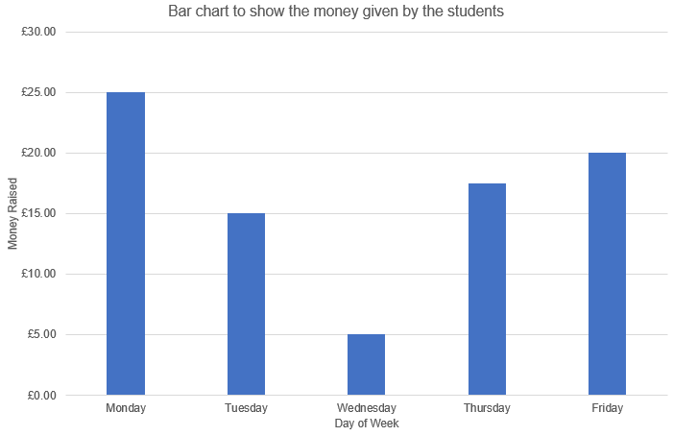

Some values on the vertical axis showing ‘Money Raised’ are missing.

**1c** Use the information given in the bar chart to complete the table below:

**(3 marks)**

|  |  |
| --- | --- |
| **Day** | **Money Given** |
| Monday |  |
| Tuesday |  |
| Wednesday |  |
| Thursday |  |
| Friday |  |

**1d** Clare tells the students that the average (mean) amount of money given by the students per day was £16.50.

Show that Clare is correct? **(2 marks)**

You **must** use calculations to justify your answer.

Show your working out and answer below:

|  |
| --- |
| Is Clare Correct? _______________ |

Clare plans to go into town next Wednesday to buy the presents.

Clare must be back by 12 noon.

She estimates that the return journey and shopping will take her 2 hours and 45 minutes in total.

**1e** If she leaves at 9.30am, will she be back by 12 noon? **(3 marks)**

You **must** use calculations to justify your answer.

Show your working out and answer below:

|  |
| --- |
| Will Clare be back by 12 noon? _____________________ |

Kate offers to go into town with Clare after work on Thursday.

They take the bus.

The distance into town is 6 miles.

It takes Kate and Clare 0.5 hour to get into town.

**1f** Use the formula below to calculate the average speed of their journey:

***Average speed = distance ÷ time***

Show your working out and answer below: **(2 marks)**

|  |
| --- |
| Average speed: _________miles per hour |

**1g** Show one way of checking your calculation in question 1f. **(1 mark)**

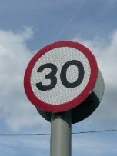

The speed limit on the journey into town is 30 miles per hour.

**1h** Give one reason why the average speed for Kate and Clare’s journey is less than 30 miles per hour. **(1 mark)**

|  |
| --- |
|  |

**Task 2 – Presents and Cards**

20% off

everything

The students wanted to buy James some golf balls.

The golf shop has a sale with 20% off everything.

Kate tells Clare that 20% is the same as ¼ off.

**2a** Is Kate correct?

You **must** use calculations to justify your answer.

Show your working out and answer below: **(2 marks)**

|  |
| --- |
| 20% is the same as ¼ ? __________________ |

A box of golf balls costs £29.95 before the sale.

**2b** How much will Clare save by buying the golf balls in the sale?

Show your working. **(2 marks)**

|  |
| --- |
| Clare will save £ _____________ |

The students wanted to buy Lucy some perfume.

Clare goes to a perfume shop.

There are 5 perfumes that Lucy likes.

The price of each perfume is shown below:

*Pearl*

*Light*

£43.95

*Baby*

*Pink*

£38.95

*Apple Blossom*

£47.50

*Green Emerald*

£39.99

*Lady Thousand*

£45.00

.

**2c** Find the range in prices of the perfume. **(2 marks)**

Show your working out and answer below:

|  |
| --- |
| Range: £ ___________ |

Clare has **eight** £5 notes, **one** £2 coin and **three** 50 pence coins.

**2d** Which of the perfumes above can she buy?

Show your working out, and justify your answer below: **(3 marks)**

|  |
| --- |
| Clare can buy: __________________________________________perfumes |

Sam made cards for James and Lucy.

Card comes in the following sizes:

|  |  |  |
| --- | --- | --- |
| Size | Width | Length |
| A1 | 594mm | 841mm |
| A2 | 420mm | 594mm |
| A3 | 297mm | 420mm |
| A4 | 210mm | 297mm |
| A5 | 148mm | 210mm |

Sam chose **A3** sized card.

**2e** What is the width of the A3 card in centimetres?

Show your working out and answer below: **(1 mark)**

|  |
| --- |
| Width: _____________________cm |

Sam made one rectangular card by folding the **A3** sheet of card in half.

**2f** Find the area of the front of the card

Use the formula:

***Area = width x length***

Show your working out and answer below: **(3 marks)**

|  |
| --- |
| Area is: _____________________________ |

Sam has taken a photograph of all the staff and students.

A local shop prints photographs in the following sizes:

**D**

203x152mm

**C**

178x127mm

**B**

152x102mm

**A**

127x89mm

**E**

254x203mm

**F**

381x254mm

Sam wants to use a photograph on the front of the card as shown below:

**2g** Advise Sam on the largest photograph he can use for the card.

Show your working out and answer below: **(2 marks)**

**Task 3 – The Farewell Party**

The students and staff plan a thank you party for James and Lucy.

60 people have said they will be going to the party.

Tony is buying the food and drinks.

Tony knows that a 2 litre bottle of cola will fill 10 plastic cups.

**3a** How many 2 litre bottles of cola should Tony buy if each person drinks 2 cups of cola? **(3 marks)**

Show your working out and answer below:

|  |
| --- |
| Number of 2 litre bottles: _________________ |

Tony assumes that he can use plastic cups for coffee.

He finds out that a famous coffee shop serves coffee between 145°F and 165°F.

The wrapper on the plastic cups states that the cups may be used for drinks up to 50°C.

The following graph may be used to convert ºFahrenheit to ºCelsius or vice versa.

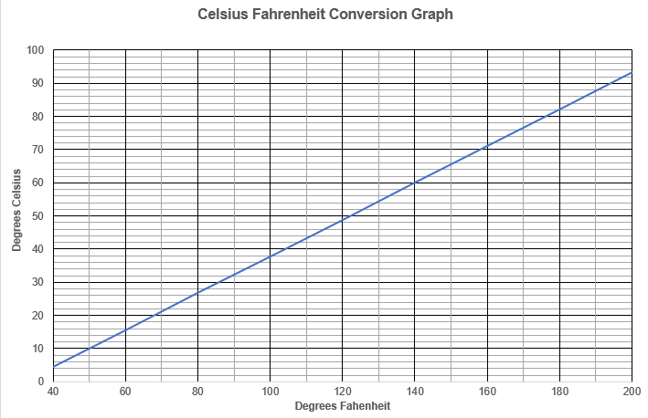

**3b** Was Tony’s assumption correct? **(3 marks)**

You **must** use calculations to justify your answer.

Show your working out and answer below:

|  |
| --- |
|  |

Tony orders 80 cupcakes from the bakery.

The number of each flavour is shown in the table below:

|  |  |
| --- | --- |
| Flavour | Number of Cupcakes |
| Chocolate | 40 |
| Lemon | 20 |
| Raspberry and White Chocolate | 20 |

Tony chooses one cupcake at random.

**3c** Draw an arrow on the scale below to show the likelihood that Tony chooses a chocolate cupcake? **(2 marks)**

Impossible Unlikely Even Likely Certain

Chance

Tony is going to order pizza for the party.

He asks the staff and students what type of pizza they would like.

He records their answers in the tally chart below:

|  |  |
| --- | --- |
| **Pizza** | **Tally** |
| Pepperoni | ~~l l l l~~ l l l l |
| Ham & Pineapple | ~~l l l l~~ l l l |

All pizzas cost £6.75 each.

Tony has £125.00 to spend on pizzas.

**3d (i)** How much change will Tony get? **(3 marks)**

Show your working out and answer below:

|  |
| --- |
| Change: £ __________________ |

**3d (ii)** Show a calculation check you could use in **3d (i).**

You could use approximation, a reverse calculation or any other suitable method.

**(1 mark)**

|  |
| --- |
|  |

Tony bought a block of ice cream for the party.

He decided to cut the block into **eight** equal sized pieces.

The ice cream block measures 32cm long by 20cm wide.

**3e** What is the length and breadth of each portion? **(3 marks)**

32cm

20cm

Show your working out and answer below:

|  |
| --- |
| Length of portion: _________________ Breadth of portion: _________________ |